1. 

2. cos(2t) = 1 – 2∙sin2t = 

3. In quadrant III, both sine and cosine are negative, sin θ = -12/13, so



4. sin x = 3∙cos x → → tan x = 3 → x = 1.249 or x = 4.391

5. Let sin x = k. Then 2k2 + 7k + 3 = 0 → (2k + 1)(k + 3) → k = -1/2 or k = -3

Since sin x ≠ -3, sin x = -1/2 → x = 7π/6 or x = 11π/6

6. If  and  is in quadrant IV,  and if  and is in quadrant II, then . So 

7. 

8. sin θ = → cos θ = , so  and since θ/2 is in quadrant II,



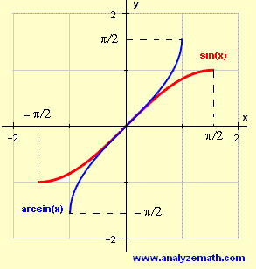9.

Sin-1­(x)

10. a) π/10 b) 0

11. ±

12. 

13. 

14. 

15. a) x (Draw the figure.) b) 1

16. Use your calculator.